**Day 2 Assignment 2**

**Questions 1:**

**Create an empty list. Accept 10 numbers from the user and append to it the list if it is an even number.**

Sol: l=[]

print("Enter 10 numbers : ")

for i in range(10):

print("Enter",i+1,"Number :")

n=int(input())

if n%2==0:

l.append(n)

print(l)

**Questions 2:**

**Create a notebook on LIST COMPREHENSION. This exercise is to put you in a Self learning mode.**

**Sol.**

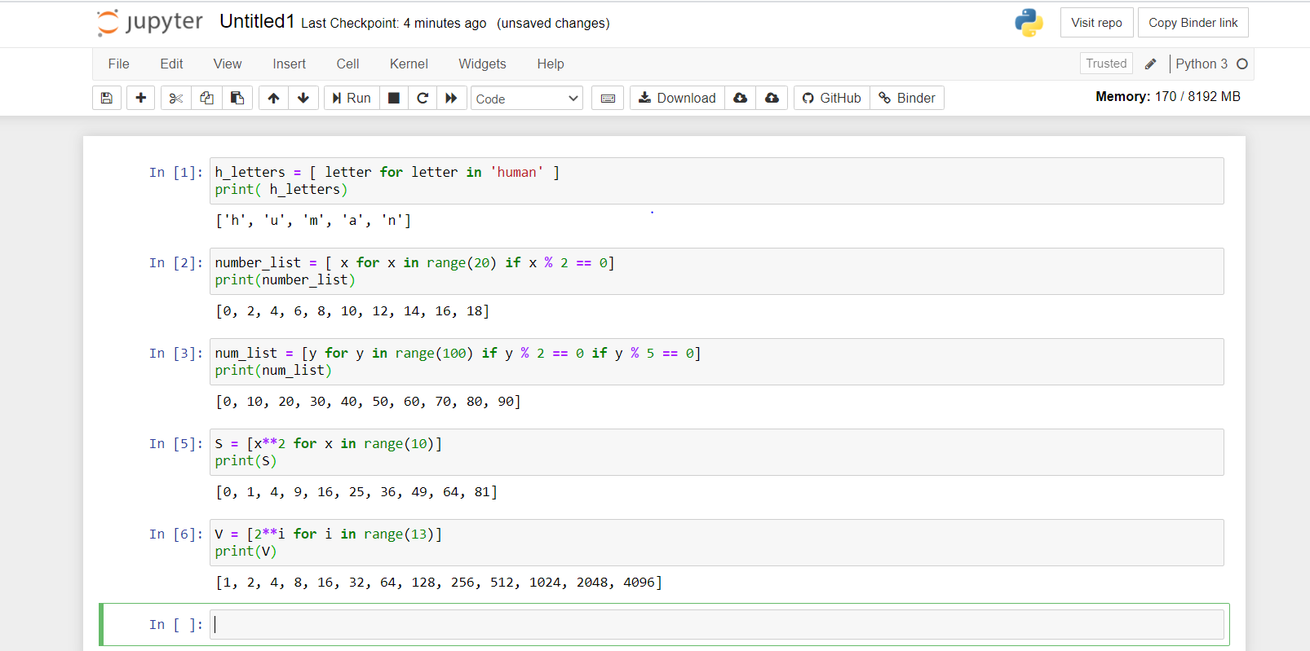

**Questions 3:**

**You have seen in the videos how powerful dictionary data structure is.**

**In this assignment, given a number n, you have to write a program that generates a dictionary d which**

**contains (i, i*i), where i is from 1 to n (both included).**

**Then you have to just print this dictionary d.**

**Example:**

**Input: 4**

**will give output as**

**{1: 1, 2: 4, 3: 9, 4: 16}**

**Input Format:**

**Take the number n in a single line.**

**Output Format:**

**Print the dictionary d in a single line.**

Sol:

n=int(input())

d={}

for i in range(1,n+1):

d[i]=i*i

print(d)

**Question 4**

**There is a robot which wants to go the charging point to charge itself.**

**The robot moves in a 2-D plane from the original point (0,0). The robot can**

**move toward UP, DOWN, LEFT and RIGHT with given steps.**

**The trace of robot movement is shown as the following:**

**UP 5**

**DOWN 3**

**LEFT 3**

**RIGHT 2**

**Then, the output of the program should be:**

**2**

**The numbers after the direction are steps.**

**Write a program to compute the distance between the current position after**

**a sequence of movement and original point. If the distance is a float, then**

**just print the nearest integer (use round() function for that and then convert**

**it into an integer).**

**Input Format:**

**The first line of the input contains a number n which implies the number of**

**directions to be given.**

**The next n lines contain the direction and the step separated by a space.**

**Output Format:**

**Print the distance from the original position to the current position.**

**Example:**

**Input:**

**4**

**UP 5**

**DOWN 3**

LEFT 3

RIGHT 2

Output:

2

Sol: import math

n=int(input())

l0=[]

x1,y1=0,0

x2,y2=0,0

for i in range(n):

l1=[]

l1=input("Enter direction and space separated by space : ").split(" ")

l0+=[l1]

for i in range(n):

if l0[i][0]=='UP' or l0[i][0]=='up':

y2+=int(l0[i][1])

elif l0[i][0]=='DOWN' or l0[i][0]=='down':

y2-=int(l0[i][1])

elif l0[i][0]=='LEFT' or l0[i][0]=='left':

x2-=int(l0[i][1])

elif l0[i][0]=='right' or l0[i][0]=='RIGHT':

x2+=int(l0[i][1])

distance=int(round(math.sqrt(pow(x2-x1,2)+pow(y2-y1,2))))

print(distance)